# Installing Bitwarden on Windows 11

1. **Allowing Inbound ports 80 & 443**

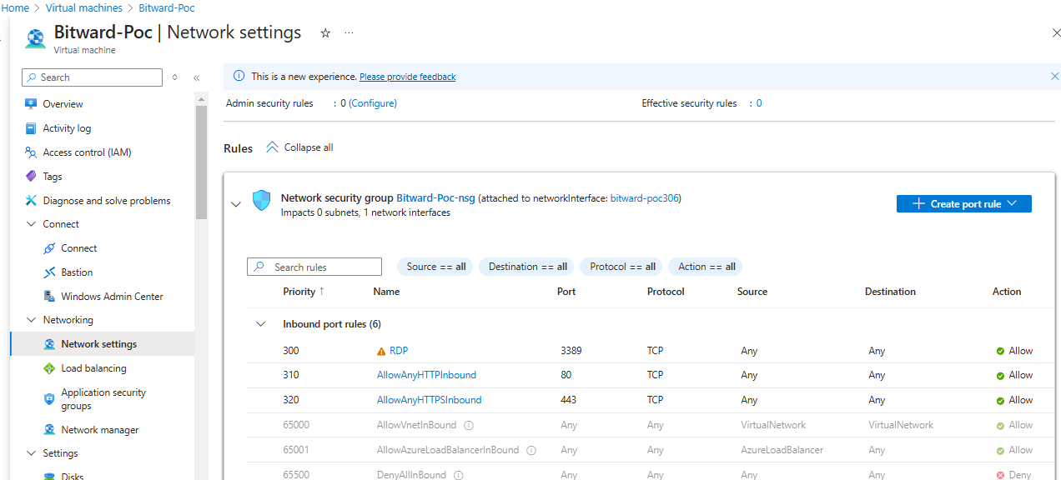

1. **Install & Setup Docker Desktop on Windows 11, Download the setup file from below link**

[Windows | Docker Docs](https://docs.docker.com/desktop/setup/install/windows-install/)

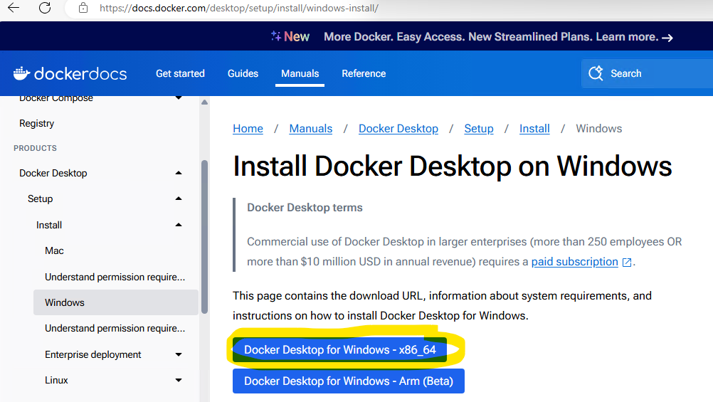

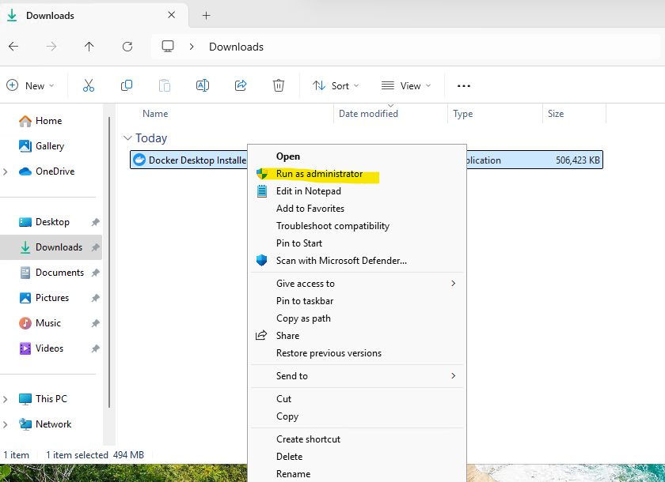

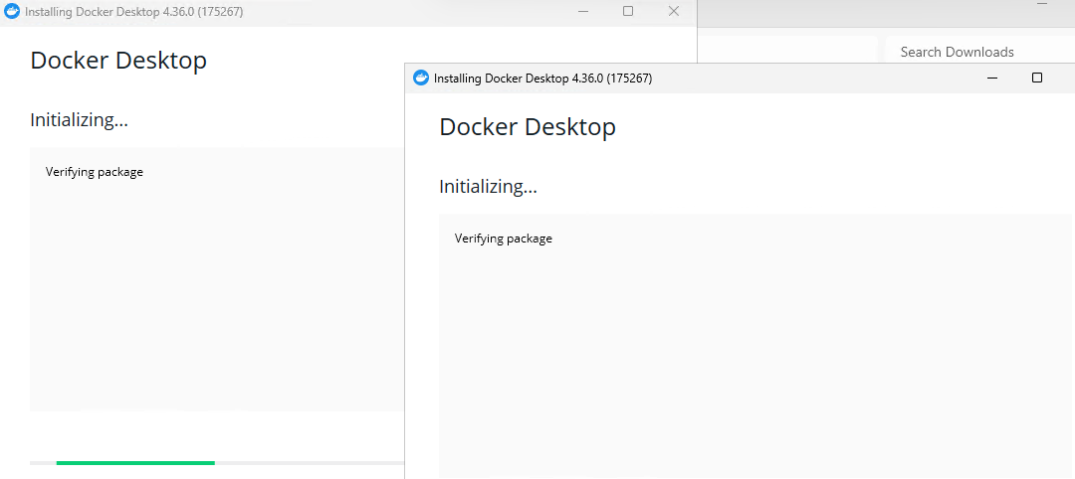

**Note:** Make sure “Use WSL 2 instead of Hyper-V (recommended) is not selected

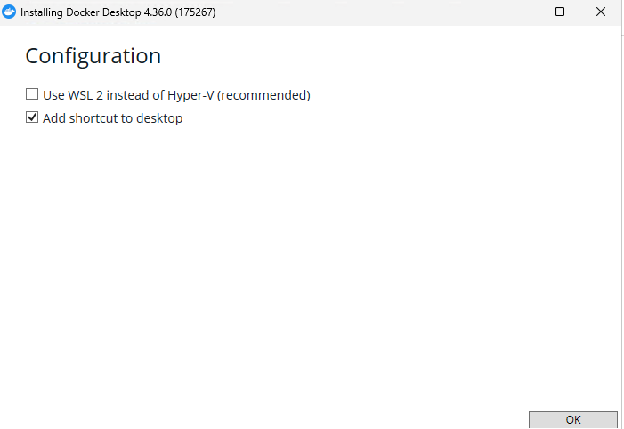

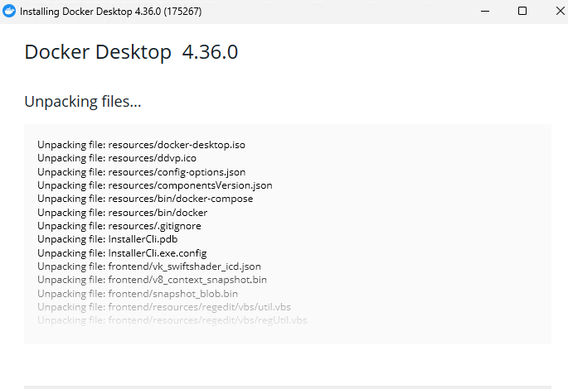

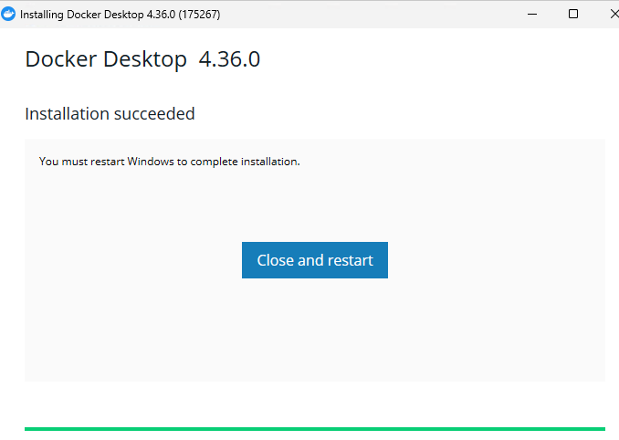



Provide Docker hub user name

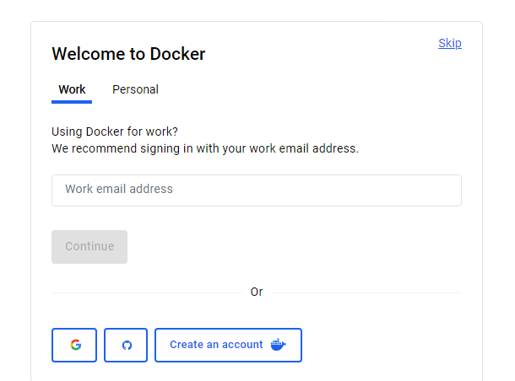

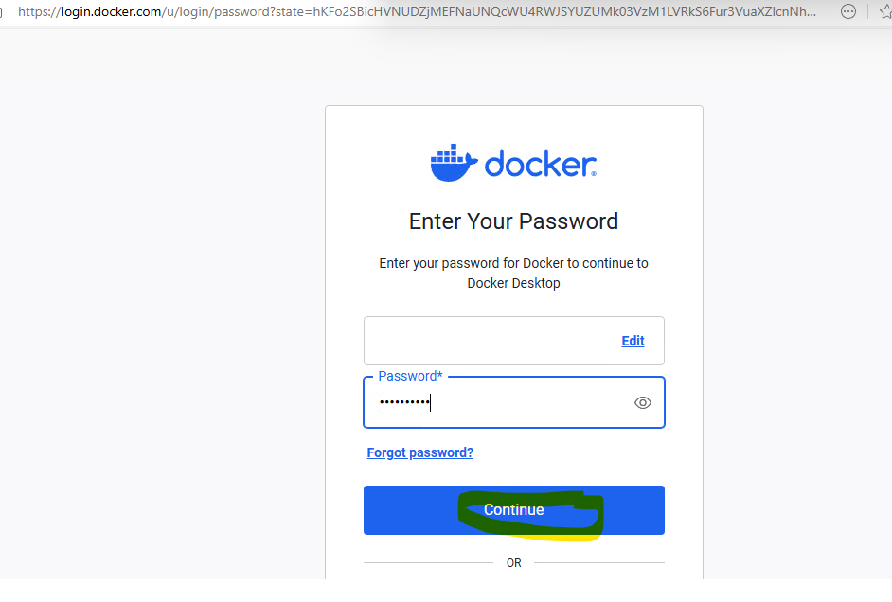

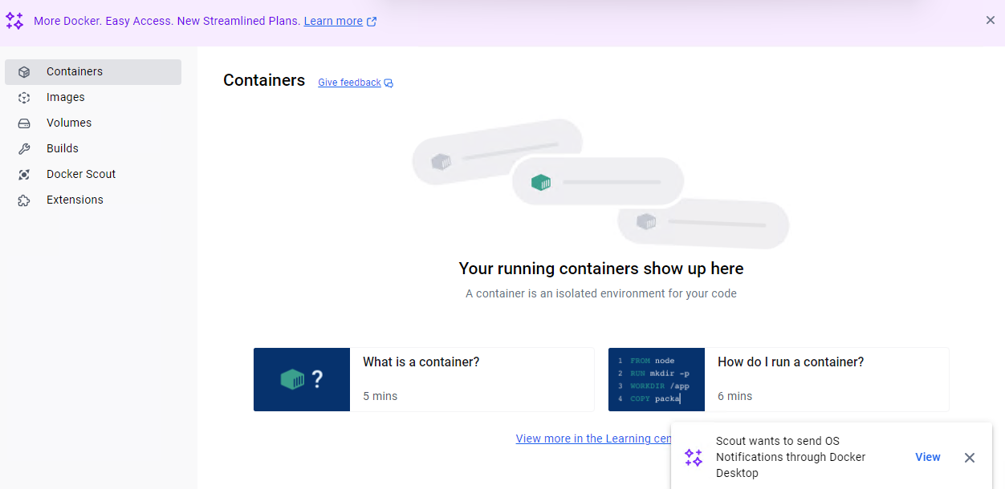

Adjust the Memory settings= 4GB as recommended by Bitwarden

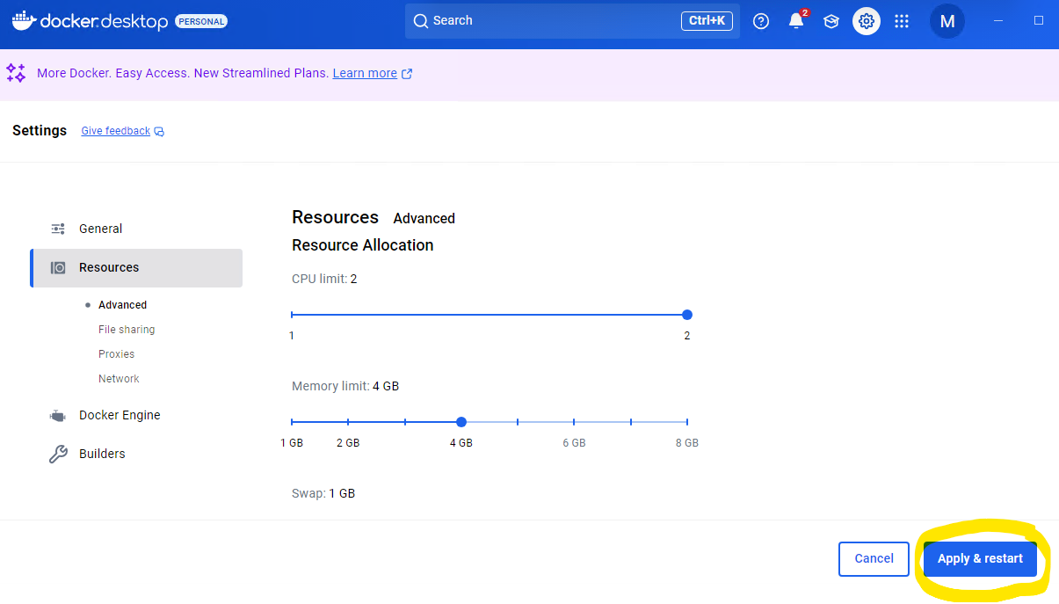

**Create Bitwarden user & directory**

$Password = Read-Host -AsSecureString

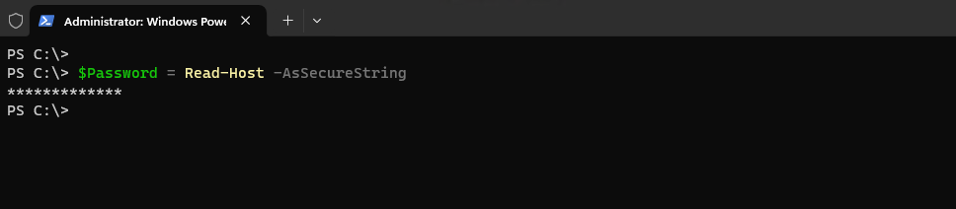

New-LocalUser "Bitwarden" -Password $Password -Description "Bitwarden Local Admin"

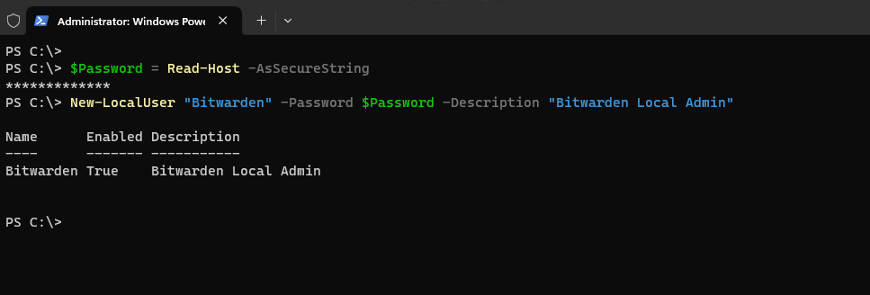

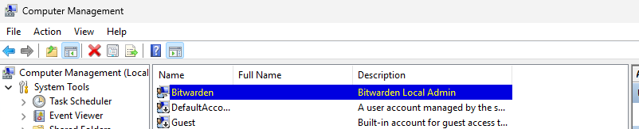

mkdir Bitwarden

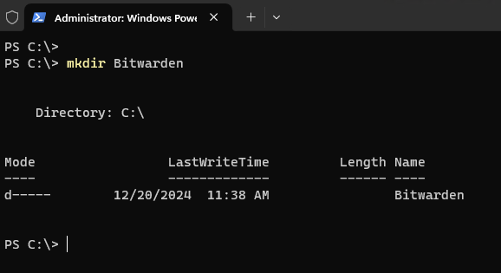

cd c:\Bitwarden

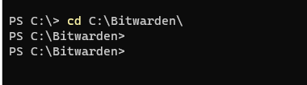

Invoke-RestMethod -OutFile bitwarden.ps1 -Uri <https://func.bitwarden.com/api/dl/?app=self-host&platform=windows>

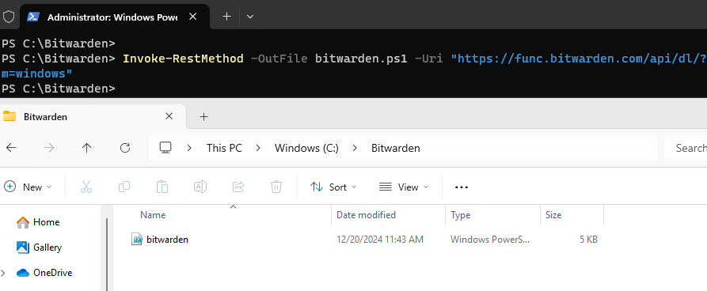

.\bitwarden.ps1 -install

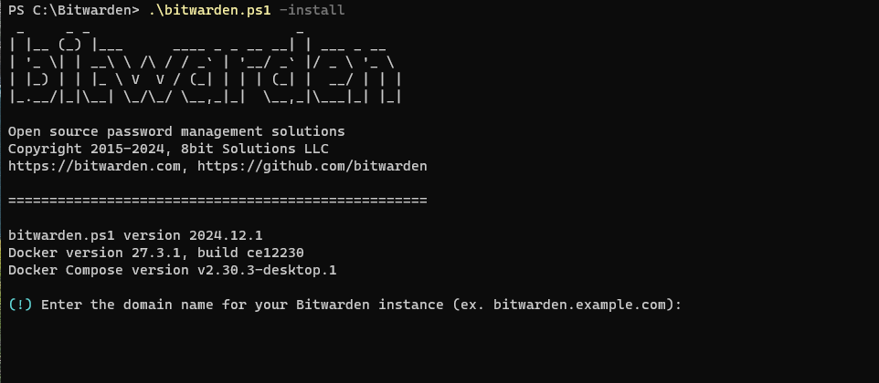

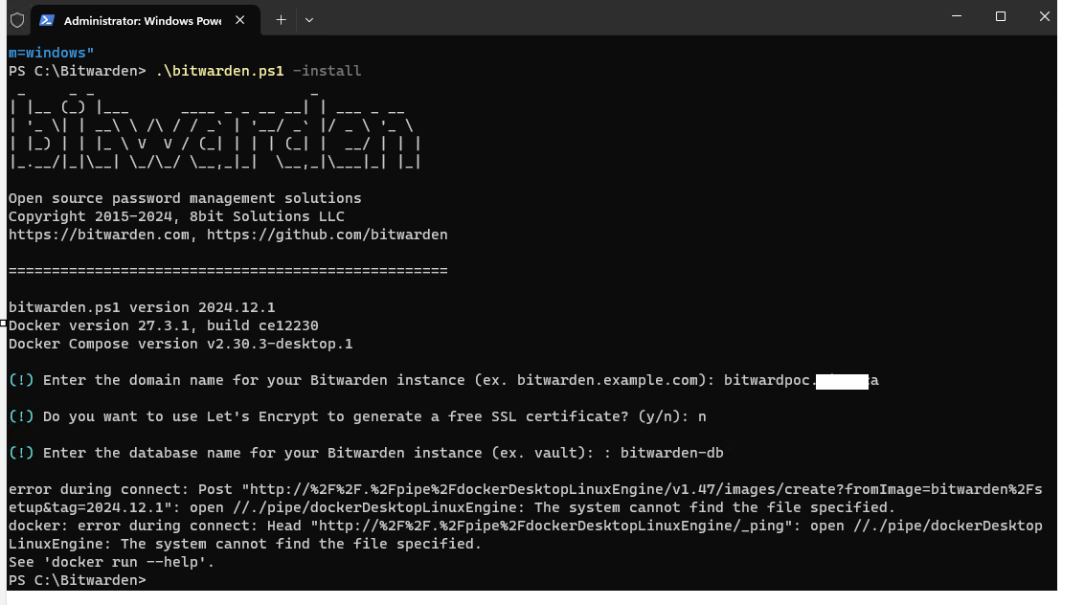

**error during connect: Post** "http://%2F%2F.%2Fpipe%2FdockerDesktopLinuxEngine/v1.47/images/create?fromImage=bitwarden%2Fsetup&tag=2024.12.1": open //./pipe/dockerDesktopLinuxEngine: The system cannot find the file specified.

docker: error during connect: Head "http://%2F%2F.%2Fpipe%2FdockerDesktopLinuxEngine/_ping": open //./pipe/dockerDesktopLinuxEngine: The system cannot find the file specified.

wsl --list --verbose

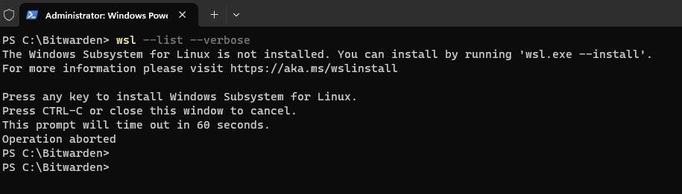

wsl.exe --install

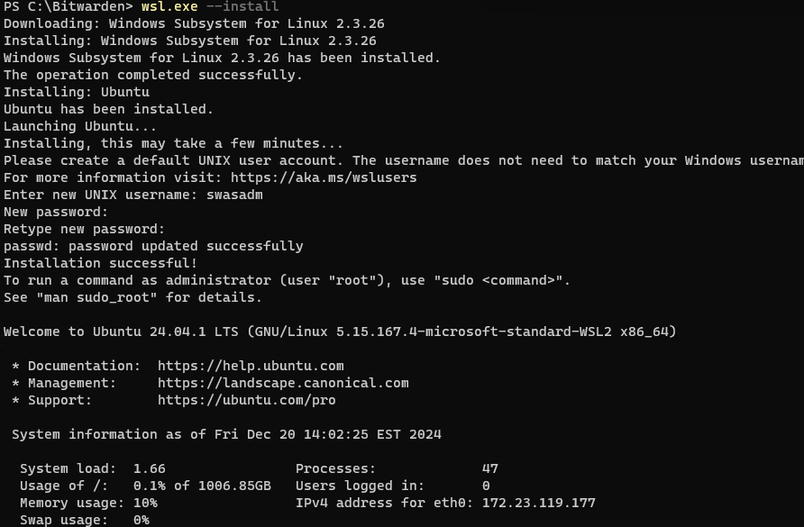

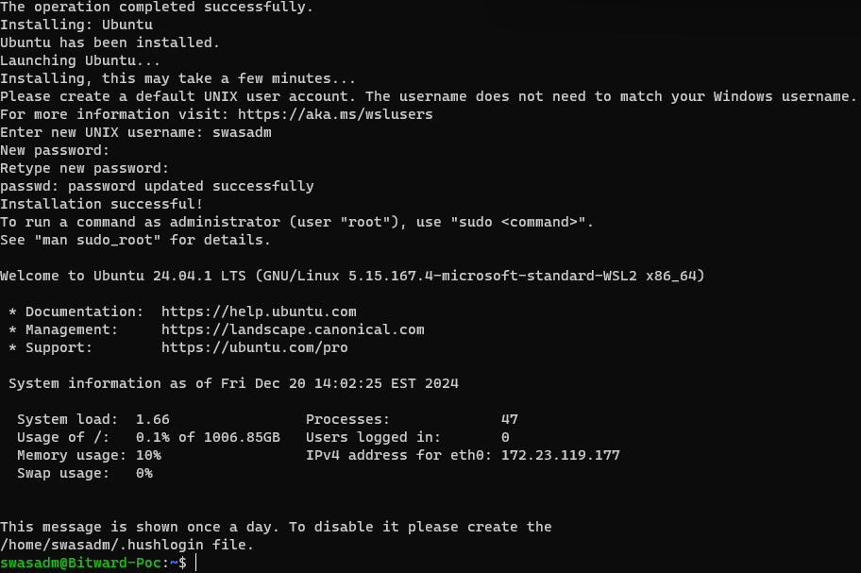

Reboot the system

Starting the Docker engineer will take approx. 3 – 5 minutes

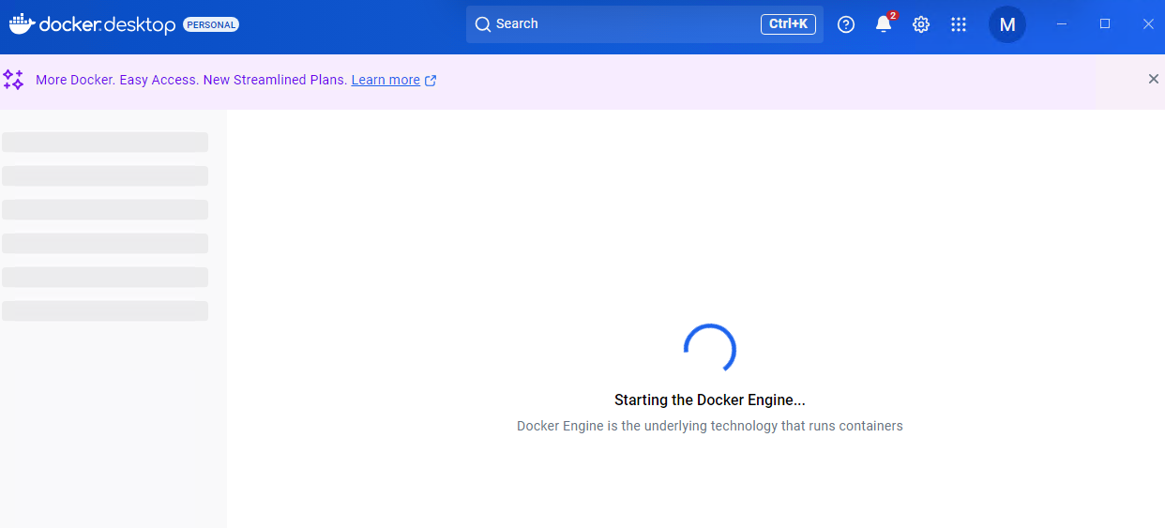

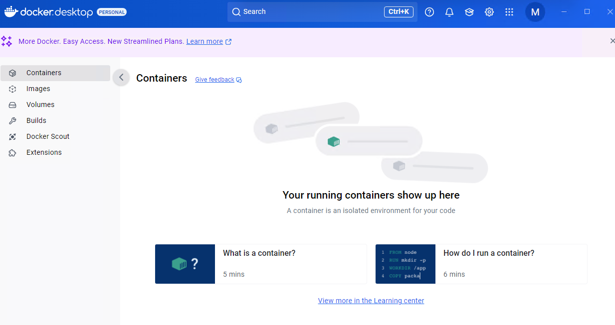

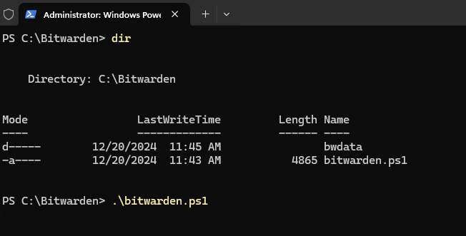

.\bitwarden.ps1 -install

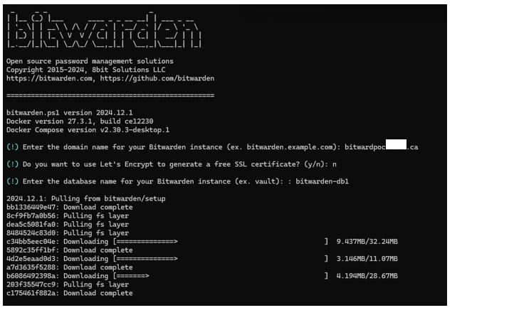

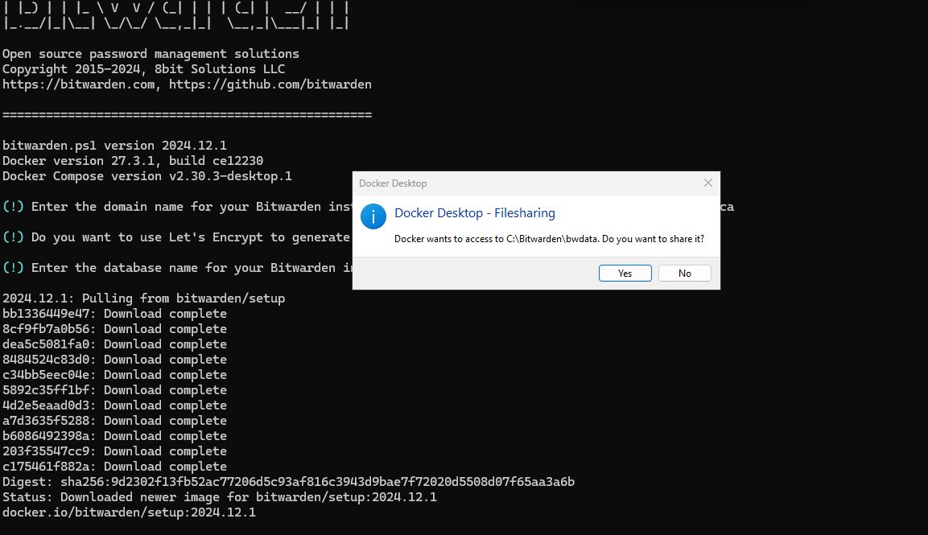

docker: error during connect: Post "http://%2F%2F.%2Fpipe%2FdockerDesktopLinuxEngine/v1.47/containers/create?name=setup": EOF.

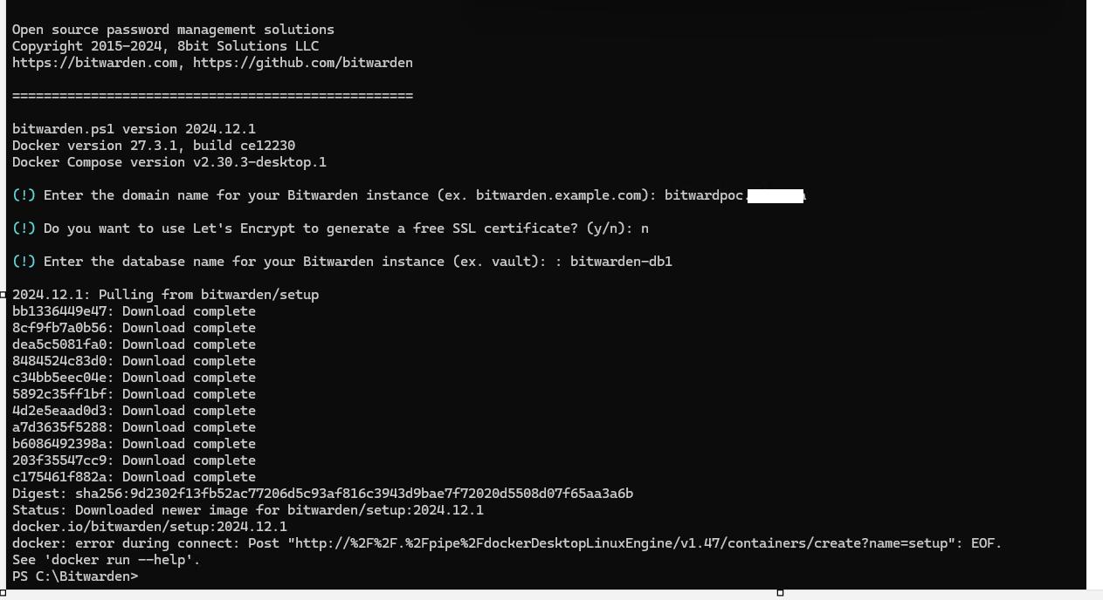

**Troubleshooting**

Restart Docker service

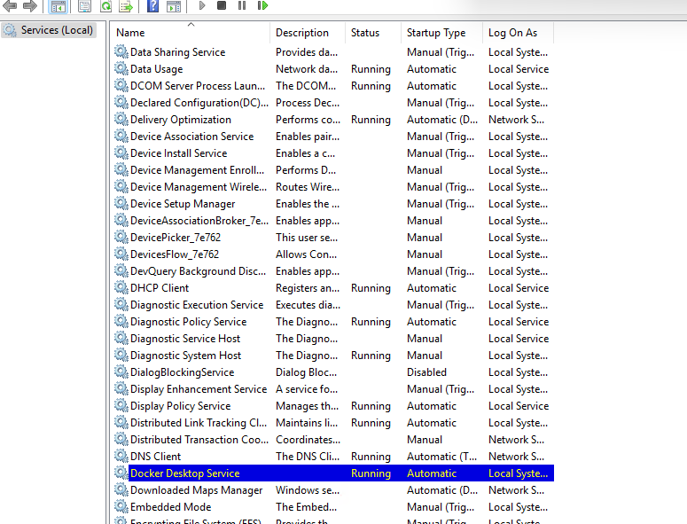

wsl --list --verbose

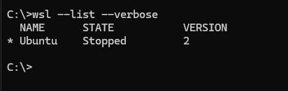

wsl --list --verbose

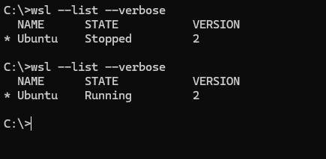

Started the Ubuntu system

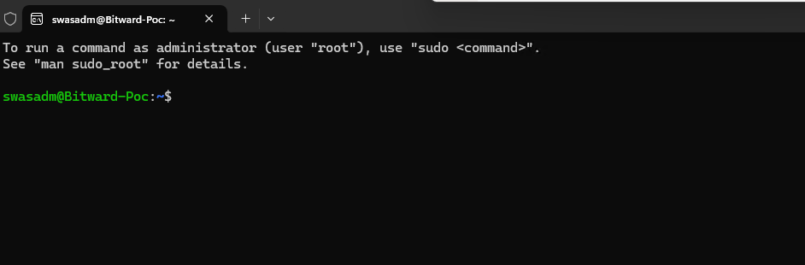

**After troubleshooting, reattempted once again to run**

.\bitwarden.ps1 -install

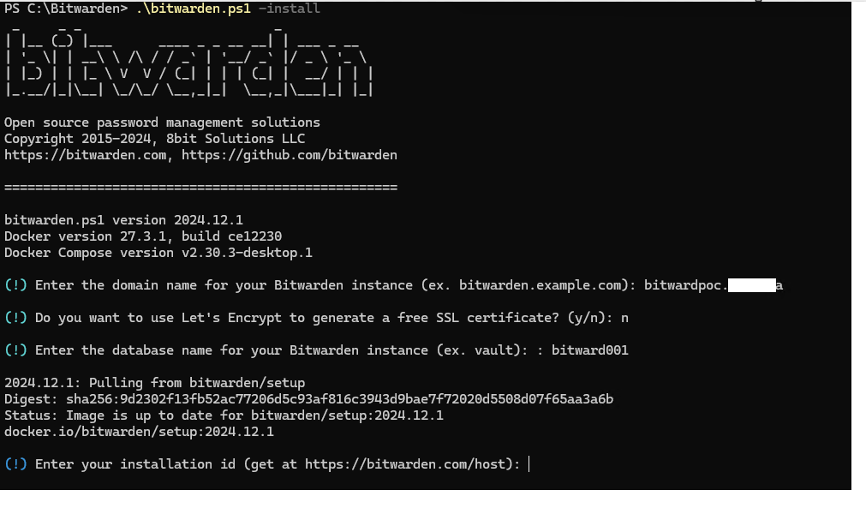

Request hosting Bitwarden Installation key Id

[Requesting Hosting Installation ID & Key | Bitwarden](https://bitwarden.com/host/)

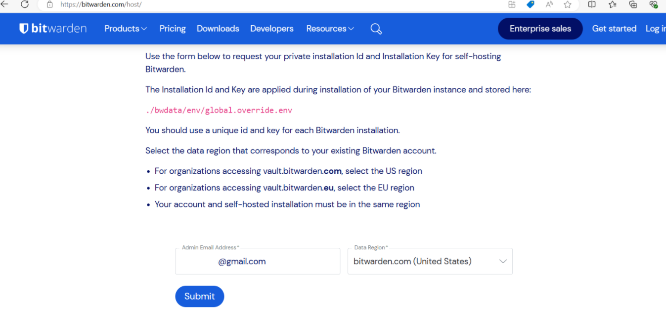

After submit

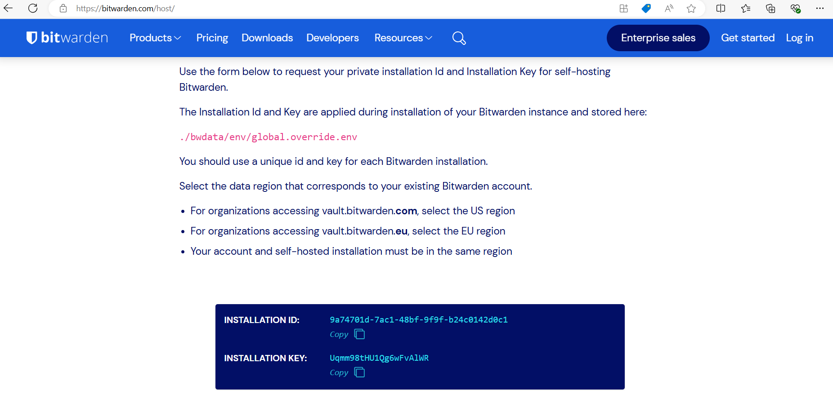

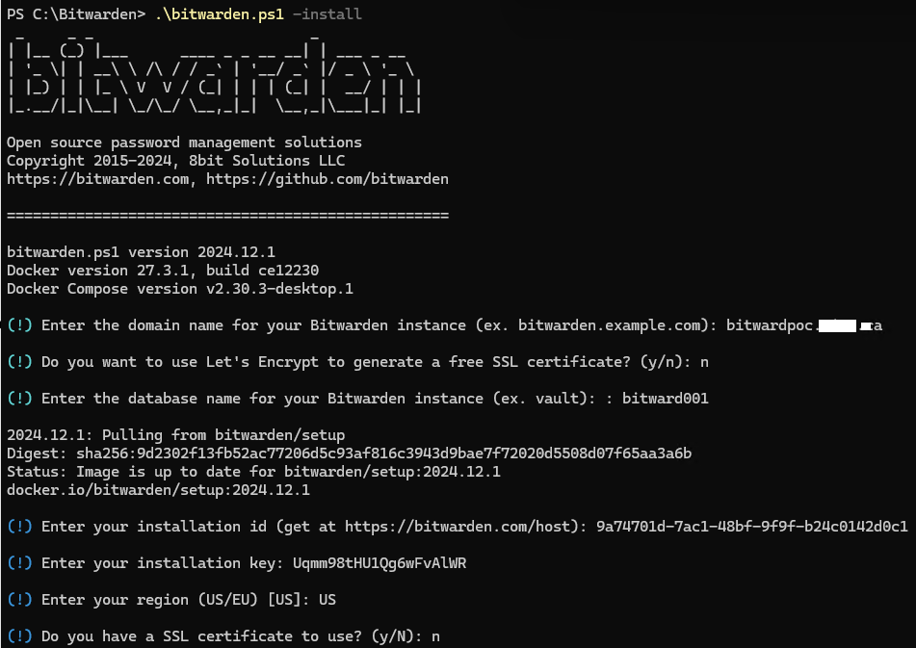

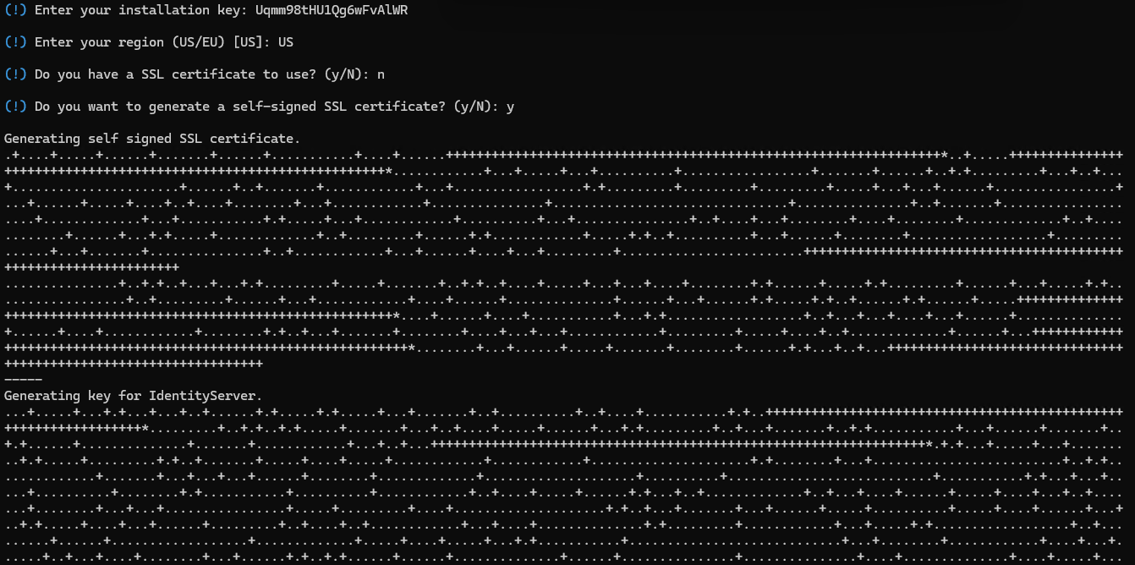

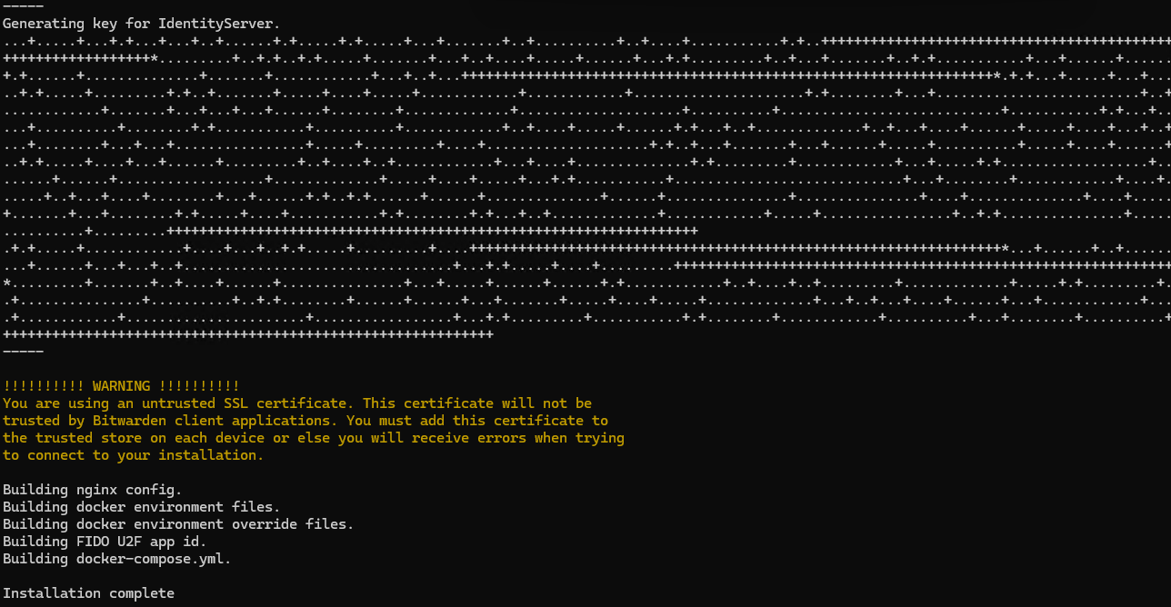

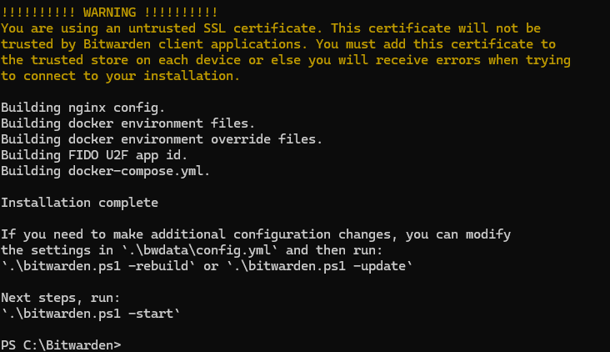

.\bitwarden.ps1 -start

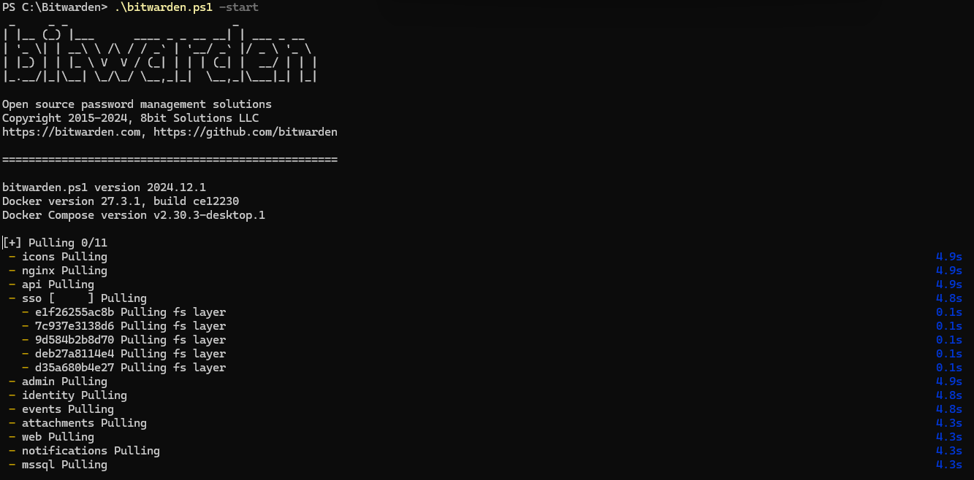

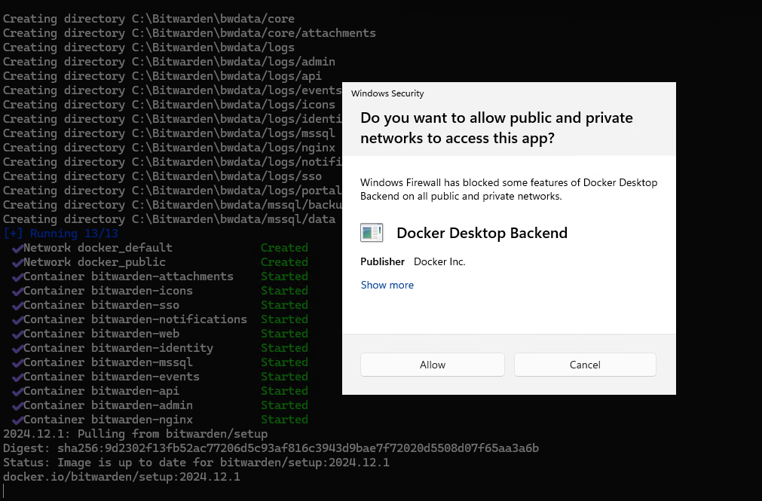

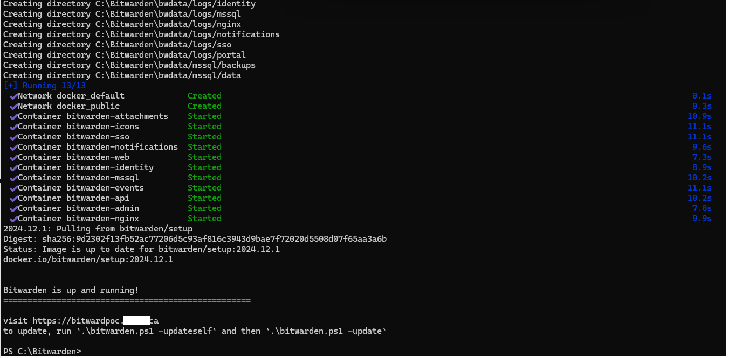

Checked from outside:

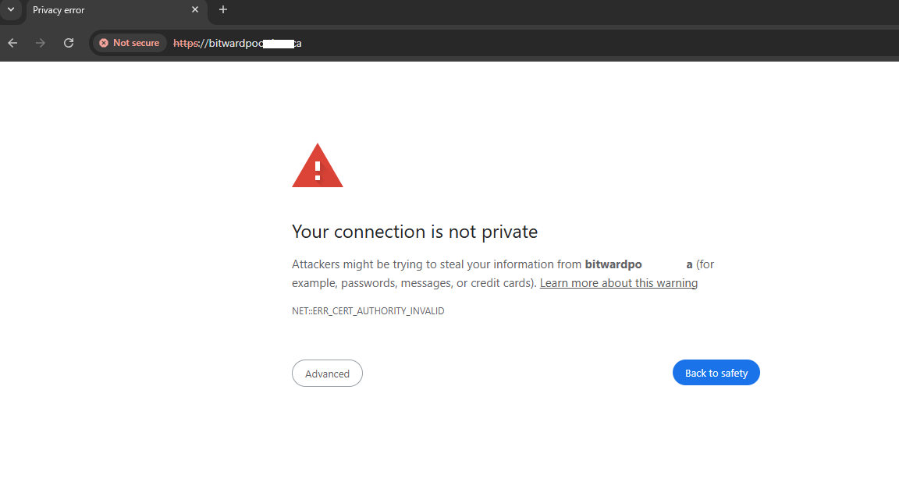

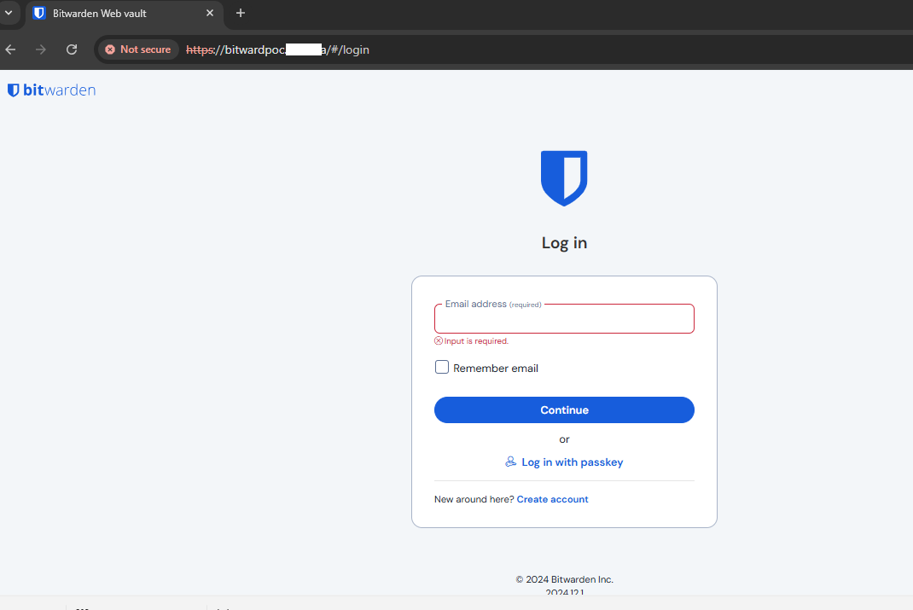

**No 3rd party ssl in use – therefore updated the internal host file on the Bitwarden machine, to access the Bitwarden console internally.**

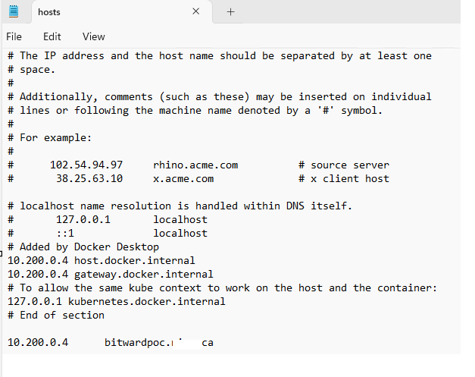

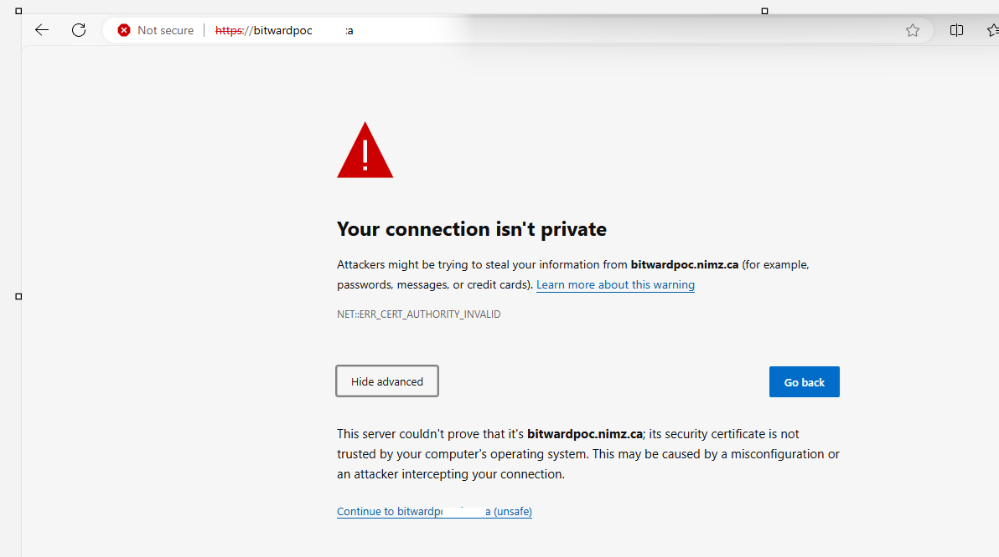

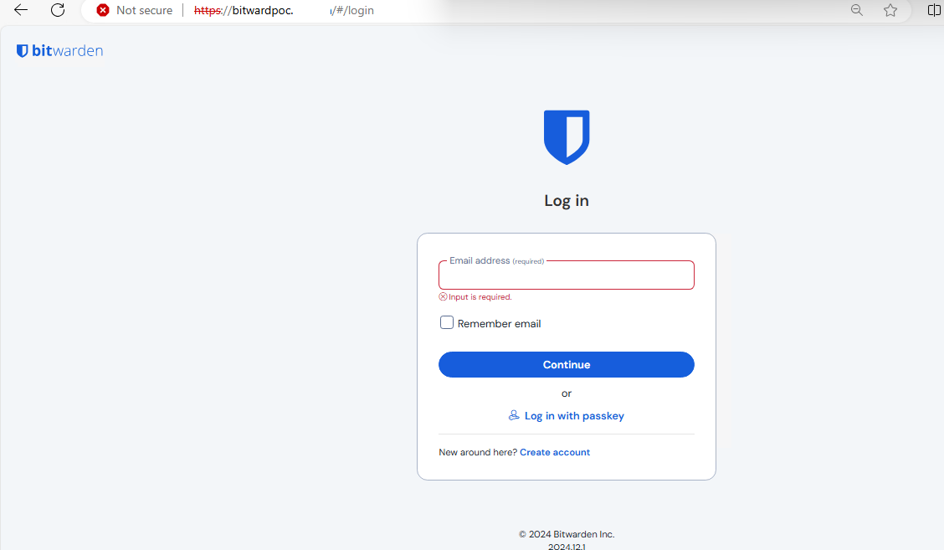

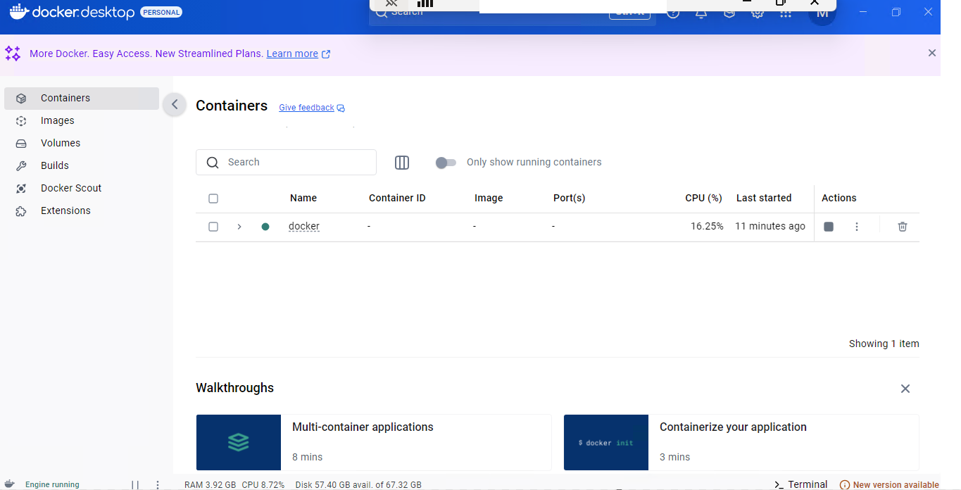

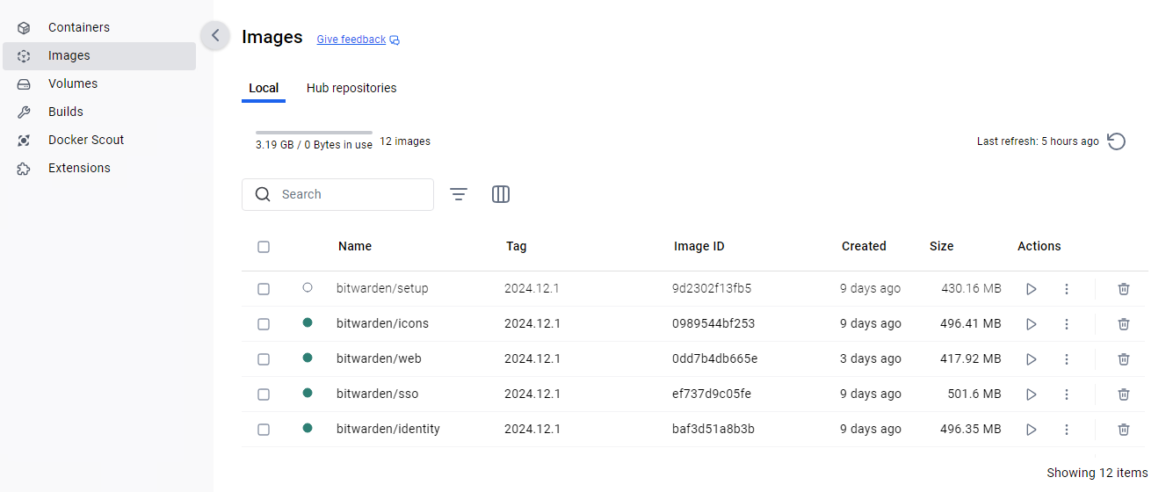

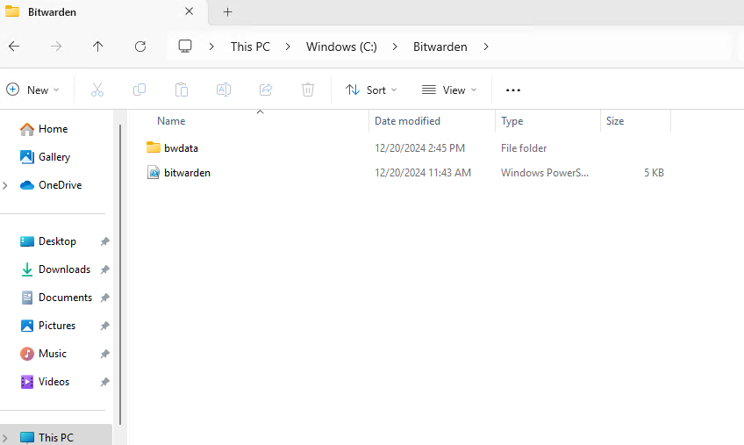

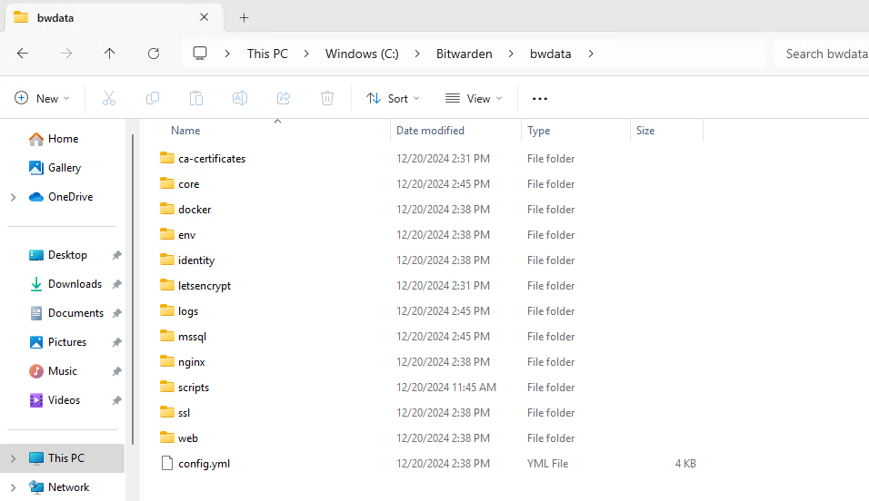

Edit the global override.env file with the following settings, open the file in Notepad with Administrator

Location of file= “C:\Bitwarden\bwdata\env”

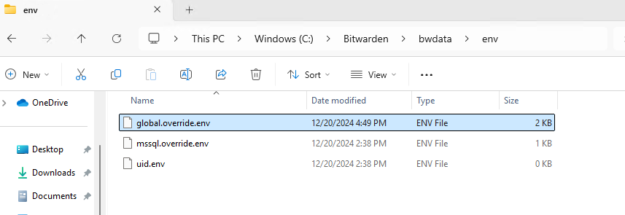

Note: Since this a test POC, No hibapikey defined

Mark the setting as= “”

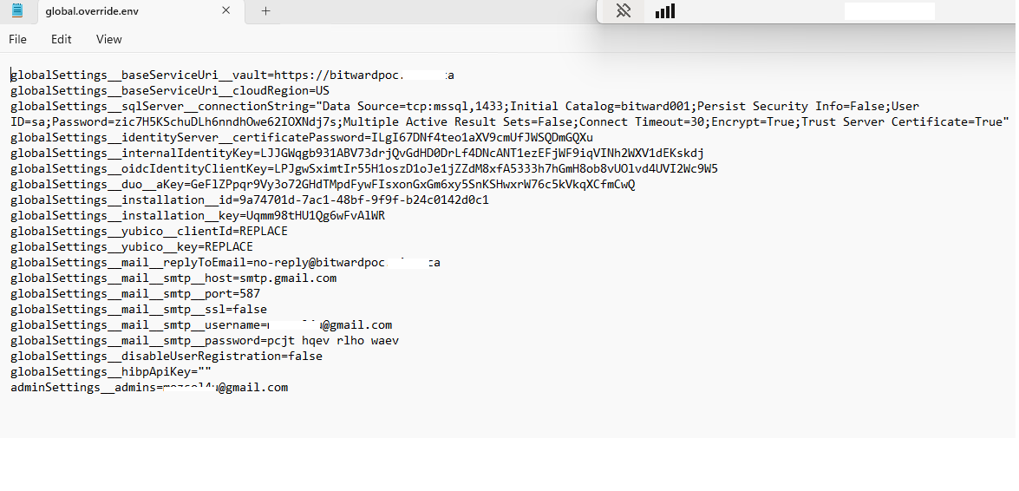

**To check the running Docker containers**

docker ps -a

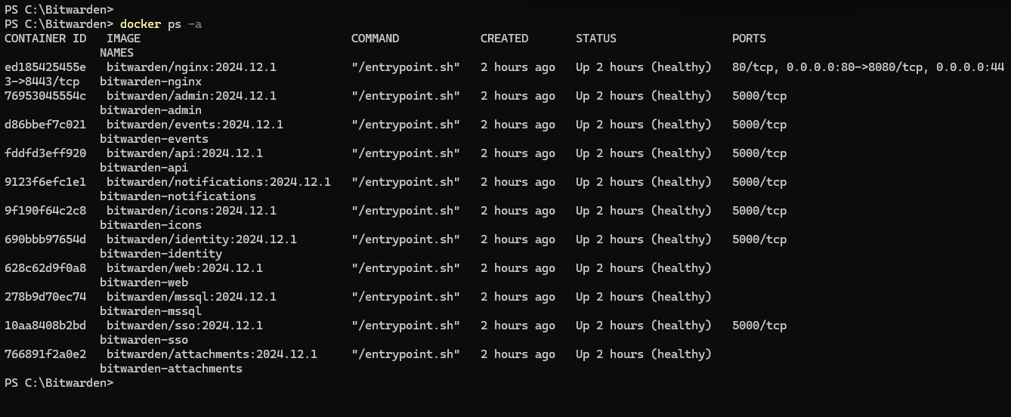

Restart Bitwarden container

.\bitwarden.ps1 -restart

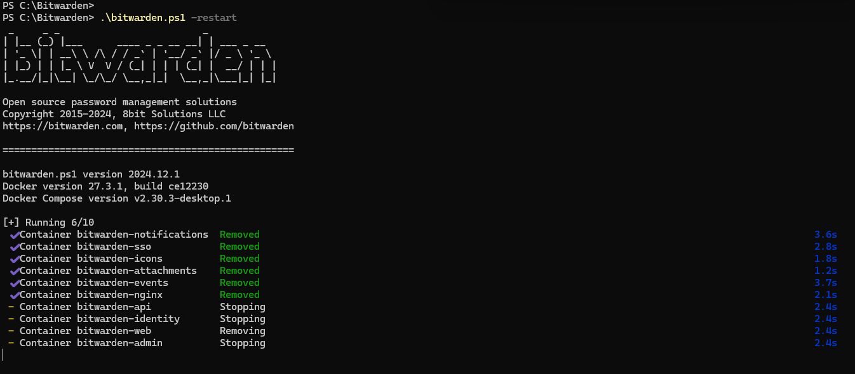

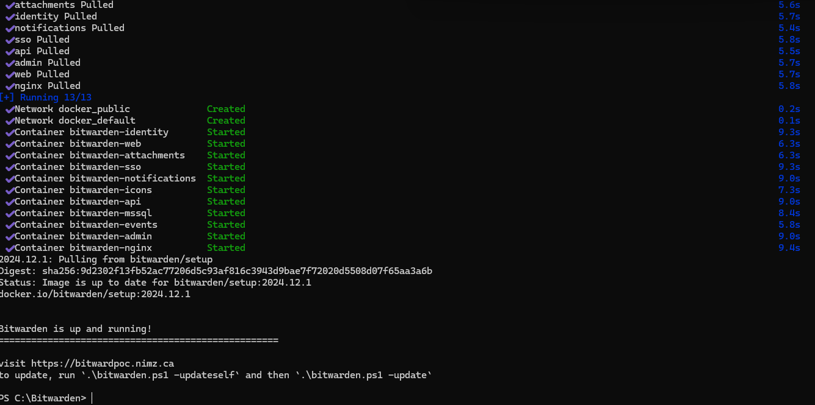

After restart the Bitwarden services, access the Bitwarden URL portal page, Click on Create Account

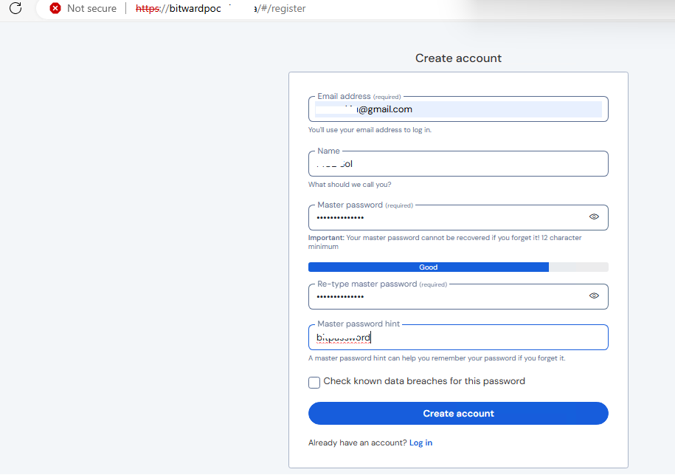

Login into Bitwarden portal, using the newly created account

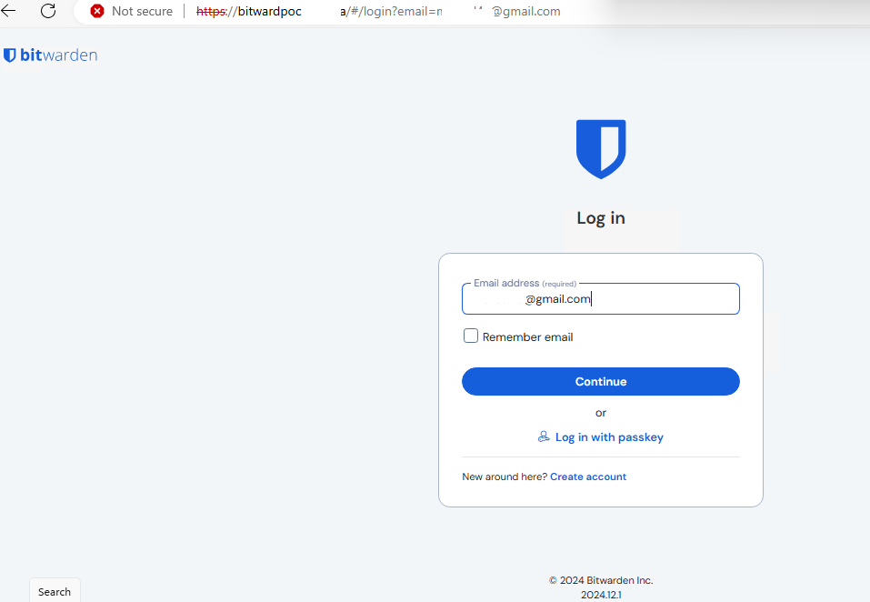

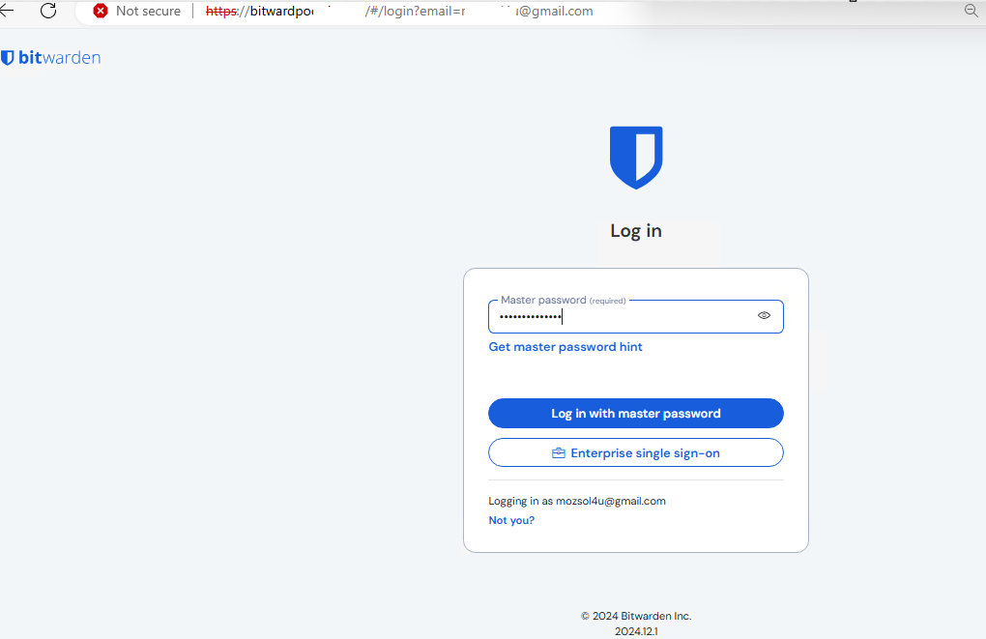

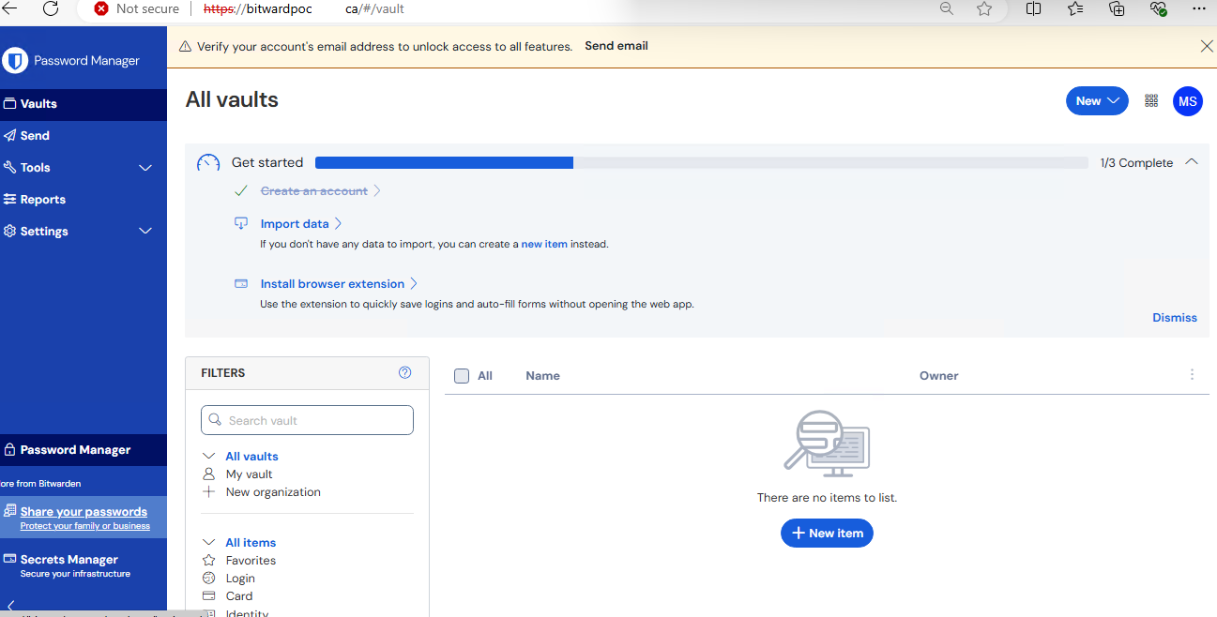

Testing of Email (SMTP) 🡪 Click on Send email

